A Regression Study on the Impact of Socioeconomic Factors on Youth Crime Rate in the United States of America

Prepared by Ivy Osei, York University

- Introduction

This study seeks to determine if a relationship exists between crime rate in the United States among youth who are young males aged 18-24, and a set of socioeconomic factors. The data is excluded to juvenile males due to the smaller number of persistent or serious female offenders in the survey. These factors include youth unemployment, police expenditures and educational background among other variables. The outcome of studies such as this may help identify which factors policy makers should consider when working on improving safety standards as it relates to crime among the young and impressionable.

Criminal justice reform remains one of the most hotly debated national issues in the U.S. There is recurring evidence that juveniles commit crime for reasons such as not doing well in school, truanting from school, poor parental discipline and supervision, peer pressure, low family income, unemployment, and high percentage of youth in the community. According to the World Health Organization, homicide is the fourth leading cause of death among youth, and 84% of the victims of these homicides are males. Although youth violence is not unique to America, studies have shown that there is a higher proportion of U.S. youths committing violent acts, illustrating the dire need for criminal justice reform in America.

This study does not seek to explain or justify any factors believed to contribute to crime rate among U.S. youth. Rather, it simply attempts to investigate if a relationship exists between crime rate and a set of socio-economic factors often mentioned in the press. The method of analysis is multiple linear regression.
- Data & Methodology

Empirical data for this study was obtained from 47 states in the U.S. The response variable (Y) is crime rate (among American youth) and is measured by the number of offences per million population. It was collected by Katy Dobson, University of Leeds.

The following five-variable multiple regression model is specified:

$$Y=B_{0}+ B_{1}X_{1}+B_{2}X_{2}+ B_{3}X_{3}+ B_{4}X_{4}+ B_{5}X_{5}+ ε,$$
where
X1 = Youth (number of young males aged 18-24 per 1000)
X2 = Education (average number of years schooling up to 25)
X3 = Expenditure (per capita expenditure on police)
X4 = Labor Force (males employed 18-24 per 1000)
X5 = Youth Unemployment (number of males aged 18-24 per 1000)

Pursuant to the purpose of this study, the regression null hypothesis is as follows:

$H_{0}=B_{1}= B_{2}=B_{3}= B_{4}=B_{5}=0$ [There is no regression relationship]

The dataset for this study is presented in Appendix1. Before the facts, it is expected that X1 and X5 will have a negative impact on crime rate among youth, that is, the sign of their regression coefficients will be positive, meaning that as the value of these independent variables increase, the mean value of crime rate will increase. A state that is highly populated in number of youth (X1) and has a high rate of youth unemployment (X5), will suggest opportunities for struggling youth to commit crimes. In the same vein, more years of schooling (X2), higher expenditure on policing (X3), and more youth in the labor face (X4) are expected to improve quality of life and reduce risk to commit crimes, meaning the signs of their regression coefficients should be negative. It is arguable that these 3 factors ensure the wholesome security of youth, leading them to have higher self-esteem, combat poverty and lead fulfilling lives. Education and employment open many doors and keeps idle minds at bay, which positively impacts youth by keeping them busy, allowing them to earn income, and prevents them from falling into the wrong crowd and leading a destructive life.

I came to select this model by conducting a model comparison in SAS to choose the best 5-variable model. Thus, State Size (in hundred thousands) and Wage (median weekly wage) were excluded from the model since they didn’t meet the criterion, all factors considered.

According to the image above, the model I selected as the best 5-variable model has the highest R-squared and the lowest MSRes and C statistic. In addition, its C statistic of 4.0961 is less than and close to k=6, making it a highly desirable model in comparison to the other ones.

- Analysis and Results

Regression results are summarized below. The F statistic of 9.90 and the p-value <.0001 in comparison to alpha = 0.05, indicates that the regression is statistically significant, and a linear relationship exists between the dependent and independent variables. The coefficient of determination (R²) suggests that about 55% of the variation in crime rate among youth is explained by the five independent variables, combined. The prediction model is as follows:

$$\hat{Y}= -197.77+1.0137X_{1}+ 1.1044X_{2}+0.8225X_{3}+ 0.1045X_{4}+0.1872X_{5}$$
The test of significance of the independent variables – measured by the t statistics – shows that not all the explanatory variables are statistically significant, namely education (X2), labour force (X4), and youth unemployment (X5). In other words, only two variables, number of male youth (X1) and police expenditure (X3), contribute meaningful information in the prediction of youth crime rate. The signs of the coefficients for the independent variables are consistent with prior expectations except for X2, X3, and X5, which were expected to be negative, of which X2 and X5 are not significant. Taking the value of the coefficient for X1 for example, it suggests that the average crime rate increases by about 1.01 for every percentage increase in number of youths per 1000.
- Test for Multicollinearity

Often, when collinearity exists, the sign of the regression coefficient is the opposite of what logic suggests. Also, the t-value may not be significant even when the F(model) is significant. To confirm that the lack of statistical significance and illogical sign associated with X2, X4, and X5, being education, labour force and youth unemployment, respectively, is not due to multicollinearity, the correlations between the independent variables are examined. The correlation half matrix is presented below.
We can’t conclude that multicollinearity is present, because the absolute values of the correlation coefficients between dependent and independent variables aren’t large. Thus, it is necessary to conduct a more rigorous analysis of multicollinearity based on the calculation of the variance inflation factor (VIF) for each of the variables, defined as follows:

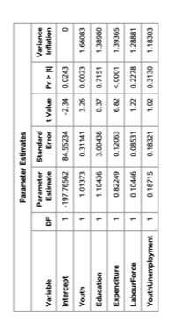
A high VIF means that the variance of the regression coefficient is large, suggesting that there is an error in ${\hat{B}}_{j}$, signifying that the regression coefficient is not desirable. A helpful rule of thumb is that collinearity exists if VIF > 10. As the table above shows, the highest VIF is 1.66083 < 10, which is too small to cause concern. With this finding, one can conclude that collinearity is most likely not a problem in the model.

- Tests for Normality and Constant Variance
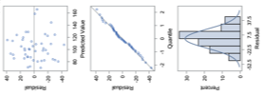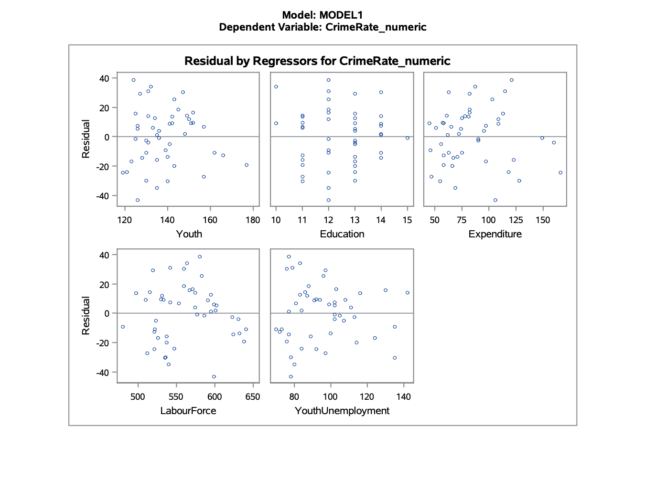
The top plot (residual vs predicted value) can be used to verify the constant variance assumption and to check the pattern of residuals. One can see that there is a problem of violation of the constant variance assumption in the top plot since as the residual decreases, the predicted values increase and they appear to fan inward. Thus, because the pattern doesn’t appear to be random as with the residual of the youth, it indicates that the data may be nonlinear and it’s necessary to transform the data. However, the middle plot (Q-Q) plot and the bottom plot (histogram of residuals) demonstrate that the data closely adhere to the normality assumption.

While the scatter of residuals appear to fan inwards, there is no definitive indication that nonconstant variance is present. Nevertheless, a popular and often effective variance stabilizing transformation is the square root transformation of only the values of Y, as follows:

$$\sqrt{Y}= B_{0}+ B_{1}X_{1}+B_{2}X_{2}+ B_{3}X_{3}+ B_{4}X_{4}+ B_{5}X_{5}$$

The regression results of this transformed model are summarized below. These results do not show a marked improvement over the original model. The coefficients have the same manner of statisitical significance as before. Also, the value of the coefficient of determination decreased from 0.5471 to 0.4901, indicating that the transformed data did not result in a better model. In addition, the residual plot vs predicted value has the same pattern as the original model. Thus, the original model remains the most effective 5-variable model of the dataset.
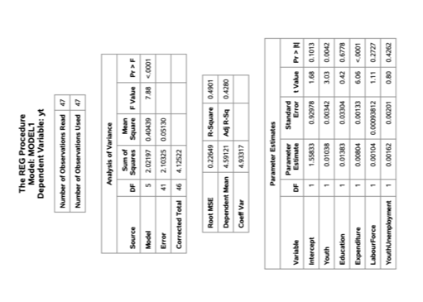
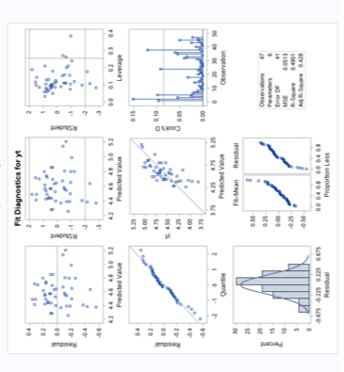
- Conclusions, Limitations and Future Improvements

This study examined the relationship between crime rate among youth and a set of socioeconomic factors. Crime rate is measured by number of offences per million population in the United States.

Results show that while number of male youth (X1), and police expenditure (X3) affect the youth crime rate, education (X2), labour force (X4) and the youth unemployment rate (X5) are ineffective predictor variables. This means that because of their high p-values, changes in these predictor variables are unassociated with changes in the response variable. However, the original model accounts for about 55% of changes in the mean youth crime rate in the United States which is an indicator that this is a capable model. More specifically, there is evidence that the crime rate in America rises in states that are highly populated with youth and quite surprisingly, states that spend more on police expenditure.

Although the coefficient of determination is reasonably high, the insignificance of three of the independent variables indicates that this model is not an accuracte predictor of the U.S. youth crime rate. The best predictor of the crime rate would be determined from the number of male youth (X1) and police expenditure (X3) parameter estimates.

A limitation to this study is the few number of observations involved and many independent variables, which could have lead to a few of the regression coefficients being insignificant. However, the nature of this study being that it examines crime rates among youth in different states, prohibits one from obtainining more observations, as there are only 50 states in the U.S.
In addition, the inability of a few parameter estimates to predict the response variable illustrates the variability and spontaneity of human nature, which is sometimes unpredictable. Nevertheless, interventions such as after-school programs for youth, and community and problem-oriented policing may reduce the crime rate in the United States, and help reduce the effect of more police expenditure and high youth population as predictor variables affecting crime rate.

Appendix

* The 47th observation is excluded from the image of the table above, due to it exceeding the size of the page*

“Preventing Involvement in Crime.” Nidirect, 16 Jan. 2018, www.nidirect.gov.uk/articles/preventing-involvement-crime.
“TEEN CRIME RISK FACTORS.” Why Do Youths Commit Crime, Teenage Crime Risk Factors, www.acs.edu.au/info/psychology/child-development/crime-risk.aspx.
“Youth Violence.” World Health Organization, World Health Organization, www.who.int/news-room/fact-sheets/detail/youth-violence.
Office of the Surgeon General (US). “Chapter 2 -- the Magnitude of Youth Violence.” Youth Violence: A Report of the Surgeon General., U.S. National Library of Medicine, 1 Jan. 1970, www.ncbi.nlm.nih.gov/books/NBK44300/.
Dobson, K. (n.d.). Crime Rate Data. Leeds; University of Leeds. https://www.sheffield.ac.uk/mash/statistics/datasets

